Caspian Pendant Lamp

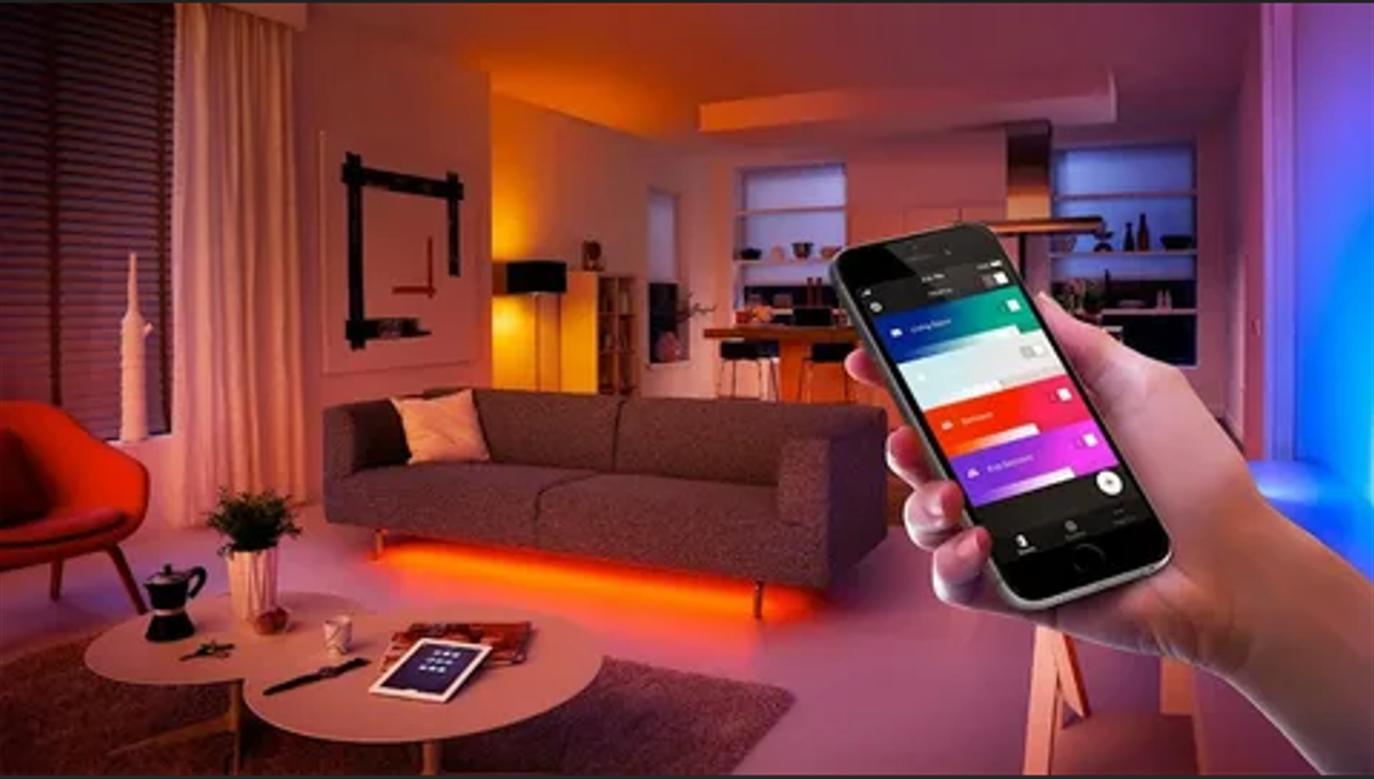

### ****Caspian Pendant Lamp****

#### ****Description:****

The **Caspian Pendant Lamp** is a stunning modern lighting fixture designed to add elegance and sophistication to any space. Its sleek, minimalist design makes it perfect for contemporary interiors, while its high-quality materials ensure durability and long-lasting performance. The lamp features a unique geometric shape that creates a captivating play of light and shadow, making it a focal point in any room.

* **Design:** Modern, geometric, minimalist.
* **Material:** High-quality metal and glass.
* **Finish:** Available in matte black, brushed brass, and polished chrome finishes.
* **Bulb Type:** Compatible with E27 LED bulbs (bulb not included).
* **Dimmable:** Yes (requires a compatible dimmer switch).
* **Installation:** Ceiling-mounted, suitable for indoor use.
* **Dimensions:** Diameter: 12 inches (30 cm), Height: 18 inches (45 cm).
* **Cord Length:** Adjustable cord length up to 59 inches (150 cm).

#### ****Key Features:****

* **Versatile Design:** Perfect for dining rooms, kitchens, living rooms, or entryways.
* **Energy-Efficient:** Compatible with LED bulbs for energy savings.
* **Adjustable Height:** The cord length can be adjusted to suit your space.
* **Easy Installation:** Comes with all necessary hardware for quick and easy installation.

#### ****Pricing:****

* **Standard Version:** $149.99
* **Premium Version (with dimmer switch included):** $179.99

#### ****Where to Use:****

* **Dining Rooms:** Creates a warm and inviting ambiance for meals.
* **Kitchens:** Provides focused lighting over kitchen islands or countertops.
* **Living Rooms:** Adds a touch of modern elegance to your seating area.
* **Entryways:** Makes a striking first impression in your home.

**Customer Reviews:**

* ⭐⭐⭐⭐⭐ "The Caspian Pendant Lamp is absolutely beautiful! It transformed my dining room into a modern masterpiece." – Sarah L.
* ⭐⭐⭐⭐ "Love the adjustable height feature. It was easy to install and looks stunning in my kitchen." – James T.
* ⭐⭐⭐⭐⭐ "The quality is top-notch, and the light it emits is perfect for creating a cozy atmosphere." – Emily R.

**How to Order:**

1. Visit our website: [www.brightworldlighting.com](http://www.brightworldlighting.com/)
2. Select your preferred finish and version (Standard or Premium).
3. Add to cart and proceed to checkout.
4. Enjoy free shipping on all orders over $100!

**Warranty and Support:**

* **Warranty:** 2-year limited warranty covering manufacturing defects.
* **Customer Support:** Contact us at [support@brightworldlighting.com](mailto:support@brightworldlighting.com) or call +1-800-123-4567 for assistance.

**Visual Representation:**

You can include high-quality images of the Caspian Pendant Lamp in different finishes and settings to showcase its versatility and design.